For the past few months, I’ve become increasingly aware of my sleeping habits in addition to how active I am throughout the day. I’ve never been a “good sleeper” – I’m constantly pulling all-nighters to study for exams or simply not getting enough sleep. In addition, after a very lazy and unmotivated fall semester, I have recently begun working out every day and making an effort to walk to my destinations as much as possible (as opposed to driving or taking the bus). Considering all of this, I decided to take advantage of this project to study three variables that I am very interested in at the moment: sleep, active minutes per day, and weight.

Upon beginning this project, I had some very strong intuitions about the data that I would collect. I was under the firm impression that, in general, more active minutes throughout the day would lead to a lower weight the next day, in addition to more sleep during that same night. This is because I was under the assumption that when my body was more active, I would be more tired and want to sleep more (in addition to weighing less because of losing water weight to sweat).

In order to assess my three chosen variables, I used very straightforward questions. The questions used to assess these items (sleep, weight, and active minutes, respectively) were as follows: How long did you sleep last night (in hours)? How much did you weight this morning (in pounds)? How many active minutes did you engage in today (as measured by your FitBit)? The data for all three items were collected by an integer input – a continuous method as opposed to binary. I could have simply used a binary response for my daily activity (Did you work out today? Yes or no), but instead, I chose to measure my daily activity through my FitBit. The FitBit measures these active minutes via metabolic equivalents (METs); active minutes qualify at or above 3 METs and are awarded after 10 continuous minutes.

Most of the data that I collected was not particularly surprising to me. The average number of hours that I slept a night was 5.4, with a standard deviation of 2.26. My sleep schedule and the amount of sleep that I get night to night tends to vary drastically while still remaining fairly low, so these results were expected. My average weight was 129.5, with a standard deviation of 3.23. I was fairly surprised by the amount of variance in my weight because I would have assumed there to be more – I typically weigh myself every day and prior to collecting this data, I would have estimated my weight to be fluctuating more on a day-to-day basis. My active minutes had an average of 47.73 and a standard deviation of 35.51. I am very surprised with this standard deviation because I wouldn’t have thought that my active minutes vary so much. Part of the reason why there was so much variance lies in the fact that a few of my data points were collected over spring break, during which I was not working out every day, nor was I walking very far.

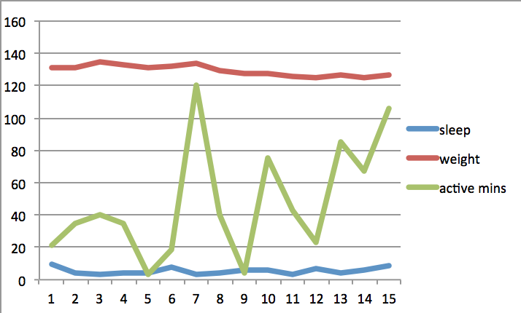 Upon plotting my data (see graph below), I found a few interesting patterns. First of all, I found that the line graph for my active minutes wildly varies. It has a general upward trend – adding a trend line to the graph gives a slope of 3.86. On the other hand, the data on my weight has a slight downward trend with a trend line slope of -0.59. My sleep has generally no upward or downward trend whatsoever – the data’s trend line has a slope of 0.064. The most interesting pattern is with my active minutes. The graph tends to jump around wildly, almost always varying from a large value one day to a much lower one the next day.

There were a few very interesting correlations among my data that I would not have expected. The first was a correlation of r = -0.272150311 between sleep and weight. According to Cohen’s standards, this is actually a medium sized correlation, which is larger than I was expecting to find between any of my data at all. This correlation means that the more I sleep, the less I weigh (or vice versa). However, upon further inspection, this isn’t too surprising because my intuition told me that if I had more active minutes from any day, I would sleep more that night and weigh less the next morning.

The next larger correlation was not too surprising – active minutes and sleep had an r = 0.507188401 when the numbers were staggered by one day (meaning active minutes from the day and hours of sleep from that very night). This correlation would actually be categorized as large by Cohen. I was not expecting to come across such a large correlation when analyzing my data, but again, this correlation in general does not surprise me. On days when I spend more time on my feet it makes sense that I would sleep more that following night.

The third and final impressive correlation that I found was between active minutes and weight, after staggering the data by one day (active minutes and the weight the next day). These two variables had an r = -0.366395206, which would again be characterized by Cohen as a medium correlation. As I mentioned earlier, this correlation did not surprise me because logically if I am spending more time on my feet then I am likely to be burning more calories and thus would weigh less on the following day.

Through the analysis of my data during this project, I definitely learned a lot about my personality and my habits. I discovered that I *do* tend to sleep more after a day that I spent a longer amount of time on my feet – if anything, this should encourage me to keep being as active as I can so that I can get into the habit of attaining a healthy amount of sleep each night. Through the data analysis I also learned that I tend to weight less when I sleep more – this could be related to the working out as well. Lastly, I confirmed my idea that following a more active day, I physically weigh less.